PROJECT REPORT
Project Title: Strategic Inventory Optimization: A Cost-Benefit Analysis of Push vs. Pull Models Date: November 21, 2025 Prepared By: Kalyan Venkata Scope: Supply Chain Optimization for NYC and LA Flagship Stores

1. Executive Summary
This report evaluates the financial viability of transitioning the NYC and LA flagship retail locations from a forecast-driven "Push" inventory strategy to a demand-driven "Pull" strategy.
Key Findings:
- Total Savings Opportunity: A full transition to the Pull model generates a combined annualized saving of $5.4 Million.
- Regional Variance: The NYC store realizes a greater relative efficiency gain (42.08% reduction) compared to LA (34.29% reduction) due to higher sales volume and inventory baselines.
- Strategic Nuance: While the Pull strategy is superior for 75% of the product portfolio, the "Hot-Feature" phone category remains more cost-effective under the legacy Push model.
Recommendation: Implement a Hybrid Inventory Strategy. Migrate High-Value (Smart) and Low-Volatility (Cold) SKUs to the Pull model immediately, while retaining the Push model for High-Volume/Low-Value (Hot-Feature) SKUs to maximize freight efficiency.

2. Methodology & Input Parameters
The analysis compares total weekly supply chain costs across two fulfillment models.

A. Input Variables & Assumptions
The following cost drivers were used to calculate the baseline:
- Smart Phone Value: $500/unit (Inventory holding cost: $20.00/week/unit).
- Feature Phone Value: $200/unit (Inventory holding cost: $8.00/week/unit).
- Shipping Costs: FedEx Overnight (Pull) vs. Standard Freight (Push).
- Picking/Packing: Standard labor rates applied to unit volume.

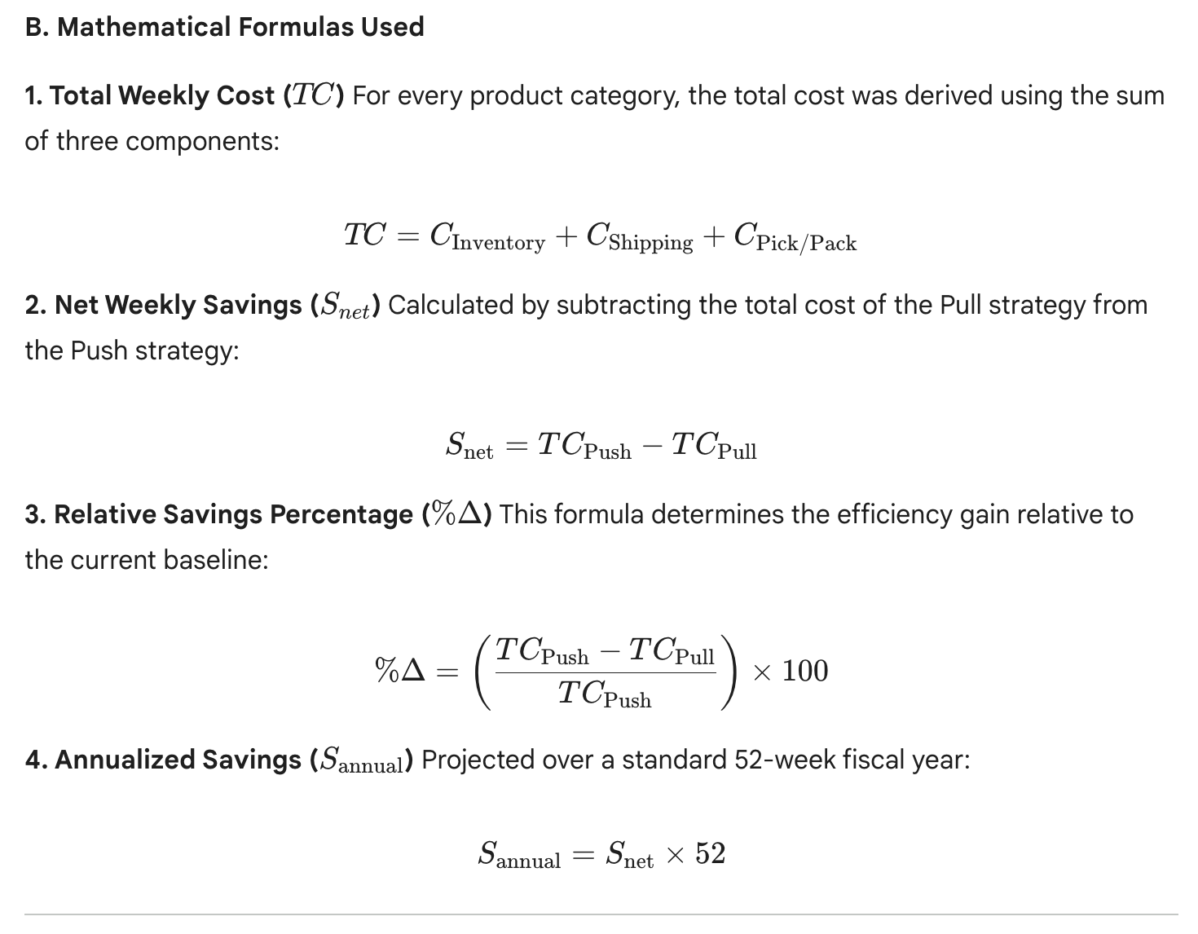

Detailed Calculation Breakdown
This section provides the step-by-step math used to derive the key financial insights for the project.

A. NYC Flagship Store Analysis
Step 1: Calculate Total Weekly Costs (All Products)
- Total Push Cost: Sum of costs for Hot-Smart, Hot-Feature, Cold-Smart, Cold-Feature under Push.
  - Calculation: $147,970.13 (Inventory)+$17,029.39 (Shipping)+$770.76 (Pick/Pack)
  - Total Push Cost = $165,770.28
- Total Pull Cost: Sum of costs for all products under Pull.
  - Calculation: $3,776.00 (Inventory)+$85,146.93 (Shipping)+$7,095.58 (Pick/Pack)
  - Total Pull Cost = $96,018.50
Step 2: Calculate Net Savings
- Math: $165,770.28−$96,018.50
- Net Weekly Savings = $69,751.78

Step 3: Calculate Savings Percentage
- Math: ($69,751.78/$165,770.28)×100
- Relative Savings = 42.08%
Step 4: Annualize the Savings
- Math: $69,751.78×52
- Projected Annual Savings = $3,627,092

B. LA Flagship Store Analysis
Step 1: Calculate Total Weekly Costs (All Products)
- Total Push Cost:
  - Calculation: $88,412.68 (Inventory)+$11,487.74 (Shipping)+$539.86 (Pick/Pack)
  - Total Push Cost = $100,440.27
- Total Pull Cost:
  - Calculation: $3,776.00 (Inventory)+$57,438.68 (Shipping)+$4,786.56 (Pick/Pack)
  - Total Pull Cost = $66,001.24
Step 2: Calculate Net Savings
- Math: $100,440.27−$66,001.24
- Net Weekly Savings = $34,439.03
Step 3: Calculate Savings Percentage
- Math: ($34,439.03/$100,440.27)×100
- Relative Savings = 34.29%
Step 4: Annualize the Savings
- Math: $34,439.03×52
- Projected Annual Savings = $1,790,829

C. The Strategic Exception (Hot-Feature Phones)
This calculation proves why the Hybrid Strategy is necessary. We compare the costs specifically for the Hot-Feature Phone category in NYC.
- Push Cost (Hot-Feature):
  - Inventory ($1,397.33) + Shipping ($359.15) + Pick/Pack ($15.86) = $1,772.34
- Pull Cost (Hot-Feature):
  - Inventory ($40.00) + Shipping ($1,795.73) + Pick/Pack ($149.64) = $1,985.37
- The Result:
  - Math: $1,772.34(Push)−$1,985.37(Pull)=−$213.03
  - Percentage: (−$213.03/$1,772.34)=−12.02%
Conclusion: The Pull strategy is $213 per week more expensive for this specific product. Therefore, we must stick with Push for Hot-Feature phones.

3. Aggregate Financial Analysis (Store-Level)
This section analyzes the total impact on the P&L if the entire store inventory is switched to the Pull strategy.

A. New York City (NYC) Flagship
- Analysis: NYC is the highest volume location. The "Push" strategy resulted in excessive inventory holding costs due to the high stock levels required to meet forecasted demand.
- Total Push Cost (Weekly): $165,770.28
- Total Pull Cost (Weekly): $96,018.50
- Net Weekly Savings: $69,751.78
- Relative Savings: 42.08%
- Projected Annual Savings: $3,627,092

B. Los Angeles (LA) Flagship
- Analysis: LA operates at a lower volume than NYC. While the savings are significant, they are proportionately lower than NYC because the "inventory burden" in the Push model was not as severe.
- Total Push Cost (Weekly): $100,440.00
- Total Pull Cost (Weekly): $66,000.96
- Net Weekly Savings: $34,439.04
- Relative Savings: 34.29%
- Projected Annual Savings: $1,790,830

4. Product-Level Analysis & Exceptions
To determine if the Pull strategy is universally superior, we analyzed savings by SKU type.

A. The Case for Pull (Smart Phones & Cold Inventory)
High-value items have high holding costs. The Pull strategy drastically reduces stock-on-hand, leading to massive savings.
- Cold-Smart Phones (NYC): 88.40% Savings. (Push Cost: $634 vs Pull Cost: $73).
- Hot-Smart Phones (NYC): 53.86% Savings. (Push Cost: $5,284 vs Pull Cost: $2,438).
- Cold-Feature Phones (NYC): 65.49% Savings.

B. The Exception: Where Push Wins (Hot-Feature Phones)
The analysis identified negative savings for one category.
- Product: Hot-Feature Phones (High Demand, Low Unit Value).
- The Data:
  - NYC Savings: -12.02% (Pull is more expensive).
  - LA Savings: -15.91% (Pull is more expensive).
- Root Cause: Feature phones have a low holding cost ($8/week). The "Push" model utilizes bulk shipping, which is cheaper per unit than the frequent, smaller shipments required by "Pull." For this specific item, logistics efficiency outweighs inventory reduction.

5. Final Conclusion & Recommendation

Conclusion
The transition from Push to Pull is not a binary choice. While the Pull model generates $5.4 million in total potential savings, a blanket application would result in operational inefficiencies for the Hot-Feature category.

Strategic Recommendation: The Hybrid Model
We recommend a targeted implementation plan:
- Immediate Transition to Pull:
  - Smart Phones (Hot & Cold): To eliminate the $20/unit holding costs.
  - Cold-Feature Phones: To reduce capital tied up in slow-moving stock.
- Retain Push Strategy:
  - Hot-Feature Phones: Continue bulk replenishment to leverage standard freight economies of scale.
Impact Statement: By adopting this hybrid approach, the organization optimizes its capital allocation, reducing unnecessary inventory spend in NYC and LA while maintaining supply chain resilience for high-velocity, low-margin goods.

